WB2020 - Whiteboard 2K20

Mentor Notes
- Ask about testing - At what point do we start
- Mocha/Chai for server, Jest for client? Jest for both?
- JSON in DB bad?
- OK if only storing theme for example? Don’t store anything that would require client or server logic to handle (e.g. analyze, search…)
- lots of text columns bad? varchar better?

Linked documents:
ERD and Wireframes
Description of Scaling
MVP, Goals, Milestones

Description

Scrum teams use a technique called relative sizing to estimate their work. The most popular technique used for sizing is planning poker. However, there is another very useful method of sizing that is quicker and often more effective than planning poker, especially for teams that have many stories to size at any given time – affinity sizing. This process works extremely well when everyone is in the same room. It’s much more difficult for geographically distributed teams. There are whiteboard apps that can be used to run a session like this, but as they are not designed for this purpose they require a lot of configuration and make the experience much less smooth than it could be. A tool well suited to visually allow a distributed team to perform affinity sizing doesn’t exist.

- Whiteboarding app that makes affinity sizing easy
- Group collaboration
- Sessions that can be saved and reviewed
- Large open whiteboard space where cards can be freely placed and arranged according to size relative to each other where left -> right is easy -> hard
  - Cards: units that the user can create, modify, and place on the board; cards represent user stories (or they can represent something else for a different user group - will worry about later eg. homework or other project component)
  - Size: the amount of work involved to get particular task done (easy or hard) - (could correspond to something else later - priority of importance for example)
- Group members take turns placing or arranging cards according to perceived relative size
  - A card from the pile can be placed or one can be moved if it’s thought it should be a different size
  - Relative sizing: to the left - smaller, to the right - bigger, underneath - the same size
  - A card that is moved too often (more than 3 times) gets removed from play and put to the side to be dealt with later
- Once card sizing arrangement is agreed upon, a sizing scale can be introduced to concretely define the sizing
  - Scale: commonly a numeric scale (fibonacci for example)
- Minor arrangement of cards into columns according to the scale is done
- In a session, team members need to be able to move cards in real time (session is updated on all clients in real-time)

Audience
The original idea is targeted to Agile scrum masters, but also has more generic use cases. Anyone running a project where estimating the amount of work is necessary would benefit. Software development to construction projects to kid’s homework...

Team Members
Linh Nguyen
Doug Ross

User Stories
Scrum Master = Host
Team Member = Participant
User = Host/Participant

Landing
Login/register Implied by session requirements

Dashboard - Host

Single session link
- Add names to list and set turn order
- People pick their name on joining, or none if onlooker
- Separate links for participants and onlookers?
Unique session link for each participant?
- To tedious and complicates things I think...

Should you be able to change the player order on the fly during the session?

Card content
- Jira info: Issue type table in database? More generic categories? Hardcoded?
- Content can be JSON to accommodate different card information formats
  - Arbitrary fields could be arbitrary
- Notes and sizing notes are separate?

Moving cards
- Can a participant put a card back and choose another card?
- Be able to undo back to original state at beginning of turn?
- Moving another card resets any previous move?

(stats bar - always visible or mouse over to show?)

Stretch features
- Jira integration to import/export ticket information
- Real-time update of cards moving across board

As a Scrum Master, I want to “write” on the board directly, so that I can make notes and stay organized
a. Add text to the board
b. Add arrows
c. Add lines
d. Delete stuff I’ve added
No not this time!!!!
Might be possible with react-whiteboard?
https://reactjsexample.com/a-whiteboard-react-component-using-svg/
If easy, maybe just allow for drawing during the session, but it’s not saved

As a Scrum Master, I want to have multiple sizing sessions, so that I can use the tool with different teams

As a team member, I want to be able to easily join a session, so that I don’t waste time
a. Account creation/sign-in not required nor desired, unless it can integrate with an identity provider (IDP)
b. It’s okay for the Scrum Master or whoever sets up sessions to need an account

As a Scrum Master, I want to import cards from whatever tracking tool I use, so that I don’t have to waste time typing stuff that exists.
a. Import csv or xml is fine
b. Fields to be imported:
i. Key (ticket id or equivalent)
ii. Issue type
iii. Summary (or title)

As a Scrum Master, I want to set an order of play, so that I can decide who plays when

As a Scrum Master, I want my sessions to be saved, so that I can refer to the results later
a. Should be able to name the sessions
b. Dates and participants should be logged
c. Other interesting metadata would be nice
i. Length of session
ii. Number of stories sized
iii. Number of participants
iv. Average story size
v. Distribution of sizes (# of 2, 3, 5 etc.)

As a Scrum Master, I want to export the results of my session, so that I can use the data elsewhere
a. CSV format is fine
b. Export the following:
i. Key
ii. Issue type
iii. Summary
iv. Size
v. Sizing notes

Whiteboard

As a Scrum Master, I want to add new cards in the app, so that I can quickly add stories we’ve just discovered
a. Fields to be allowed on entry:
i. Key (optional)
ii. Summary/title (required)
iii. Notes (optional)

As a Scrum Master, I want team members to be identified, so I know who is participating
a. Person’s name is fine
b. Can be entered by the Scrum Master in advance
c. Can also be entered or edited by team members as they join

As a team member, I want to know whose turn it is, so that I don’t get confused

As a team member, I want to know when it will be my turn, so that I can prepare

As a Scrum Master, I want to limit each team member to one move per turn, so that everyone participates
a. One move = moving only one card

As a team member, I want to be able to change my mind about where I put my card before my turn ends
a. Player can put the card down and then move it again

As a Scrum Master, I want to replicate the experience of using a whiteboard as closely as possible, so that the sizing technique is effective

As a team member, I want to be able to move cards freely on the board, so that it’s easy to size things

As a Scrum Master, I want to prevent people from moving cards to some areas on the board, so that I can stay organized
a. Separate area for cards taken out of play

As a Scrum Master, I want to be able to label the left and right sides of the board, so that I can set the ground rules for the game

As a team member, I want to access the rules of the game, so I understand what I need to do

As a Scrum Master, I want a story that has been moved more than 3 times to be automatically taken out of play so that we can review it in more detail later

As a Scrum Master, I want all unsized stories to be kept together in a separate location on the board, so we can see how much we must do

As a Scrum Master, I want all unsized stories to be visible, so that team members can see what they are sizing

As a Scrum Master, I want all unsized stories to be in a separate location on the board, so we can clearly see the work left to do

As a Scrum Master, I want all sized stories to be visible so that team members can see them

As a Scrum Master, I want to see real time progress of my session so I can manage my time appropriately
a. # of stories unsized
b. # of stories sized
c. # of stories taken out of play
d. Current running time of session

As a Scrum Master, I want to decide which sizing reference I’m using, so that I have flexibility
a. Modified Fibonacci (1,2,3,5,8,13,20,40,100)
b. Fibonacci (1,2,3,5,8,13,21,34,55,89)
c. Powers of 2 (2,4,8,16,32,64,128)
d. T-shirt (xxs,xs,s,m,l,xl,xxl)
(maybe scale or sizing_reference table in db - Stretch: Add/Edit list of scales)

As a Scrum Master, I want to apply the sizing reference of my choice after all stories have been sized, so that I can validate the sizing with the team
a. Size appears at the top of the column
b. Would be nice if the size appeared on the card as well
(Stretch: automatically detect column that card is under?)

As a Scrum Master, I want to decide where in my sizing reference to start, so that I have flexibility
a. E.g. if using Fibonacci, I should be able to make the first column whatever number I decide, rather than it always needing to be 1.
b. It should be smart enough to tell me if I’m starting too far into the series and I don’t have enough numbers left for all the columns

As a Scrum Master I want to add sizing notes to the cards, so that I can record any constraints or assumptions made during sizing

As a Scrum Master, I want to change the colour of the cards, so that I can have a visual indicator of the type of requirement
a. Would be cool if it could change the card colour automatically based on the issue type

As a user, I want the board size to adjust based on the amount of content on the board
a. Board should not be a set size, but rather be “infinite”
b. Can pan to see other parts of the board
c. Can zoom to look at things more closely
d. Cards should always remain readable at normal zoom level – i.e. do not make the cards smaller to stay within a constrained board size
(use <canvas>)

Wireframes

Landing page
- Login/signup are modals here
- Basic username/password authentication
- Stretch: Email verification
- Super stretch: IDP/SSO login

Dashboard page
- Brought here from landing page login
- Manage sessions
- Logout returns to landing page

Whiteboard session page
- Brought here from dashboard
- Brought here via invite link
- Can close the session and return to the dashboard

Entity Relationship Diagram

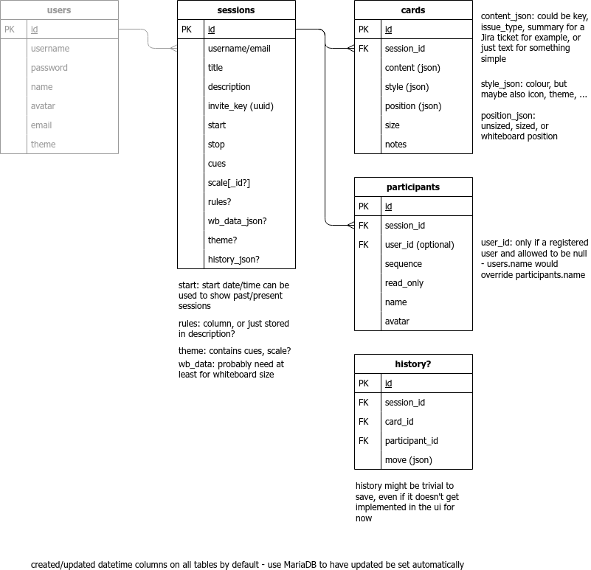

Stack Choices

Back-end (API server)
- Node.js
- Postgres
- Mocha/Chai? Jest?

Front-end
- Node.js (content server)
- React - create-react-app
- MaterialUI? Something supporting whiteboard - HTML <canvas>
- Webpack/Babel
- Storybook
- Jest/Cypress

Deployment
- AWS (look into best solution, continuous integration)

Original User Stories

1. As a Scrum Master, I want to import cards from whatever tracking tool I use, so that I don’t have to waste time typing stuff that exists.
a. Import csv or xml is fine
b. Fields to be imported:
i. Key (ticket id or equivalent)
ii. Issue type
iii. Summary (or title)
c. Stretch: An actual integration with Jira that allows querying through the app would be awesome

2. As a Scrum Master, I want to add new cards in the app, so that I can quickly add stories we’ve just discovered
a. Fields to be allowed on entry:
i. Key (optional)
ii. Summary/title (required)
iii. Notes (optional)

3. As a Scrum Master, I want to have multiple sizing sessions, so that I can use the tool with different teams

4. As a Scrum Master, I want my sessions to be saved, so that I can refer to the results later
a. Should be able to name the sessions
b. Dates and participants should be logged
c. Other interesting metadata would be nice
i. Length of session
ii. Number of stories sized
iii. Number of participants
iv. Average story size
v. Distribution of sizes (# of 2, 3, 5 etc.)

5. As a Scrum Master, I want team members to be identified, so I know who is participating
a. Person’s name is fine
b. Can be entered by the Scrum Master in advance
c. Can also be entered or edited by team members as they join

6. As a team member, I want to be able to easily join a session, so that I don’t waste time
a. Account creation/sign-in not required nor desired, unless it can integrate with an identity provider (IDP)
b. It’s okay for the Scrum Master or whoever sets up sessions to need an account
7. As a Scrum Master, I want to set an order of play, so that I can decide who plays when

Single session link
Add names to list and set turn order
People pick their name on joining, or none if onlooker, or:
Separate links for participants and onlookers?
Unique session link for each participant?

8. As a team member, I want to know whose turn it is, so that I don’t get confused
9. As a team member, I want to know when it will be my turn, so that I can prepare

Change order up on the fly?

10. As a Scrum Master, I want to limit each team member to one move per turn, so that everyone participates
a. One move = moving only one card
11. As a team member, I want to be able to change my mind about where I put my card before my turn ends
a. Player can put the card down and then move it again

Be able to undo back to original state at beginning of turn?
Moving another card resets any previous move?
Stretch: real-time update of cards moving across board

12. As a Scrum Master, I want to replicate the experience of using a whiteboard as closely as possible, so that the sizing technique is effective
(research more into what the experience of using physical whiteboard is like)

13. As a team member, I want to be able to move cards freely on the board, so that it’s easy to size things

14. As a Scrum Master, I want to prevent people from moving cards to some areas on the board, so that I can stay organized
a. Separate area for cards taken out of play

15. As a Scrum Master, I want to be able to label the left and right sides of the board, so that I can set the ground rules for the game
(Small ----------> Big)
(Easy ----------> Hard)
in top left/right corners

16. As a team member, I want to access the rules of the game, so I understand what I need to do
(icon that if click on gets pop up of rules - Scrum Master write rules)

17. As a Scrum Master, I want a story that has been moved more than 3 times to be automatically taken out of play so that we can review it in more detail later
(moves to different bin)

18. As a Scrum Master, I want all unsized stories to be kept together in a separate location on the board, so we can see how much we must do
19. As a Scrum Master, I want all unsized stories to be visible, so that team members can see what they are sizing
20. As a Scrum Master, I want all unsized stories to be in a separate location on the board, so we can clearly see the work left to do
(sidebar/gallery at bottom, or on the board itself?)

21. As a Scrum Master, I want all sized stories to be visible so that team members can see them

22. As a Scrum Master, I want to see real time progress of my session so I can manage my time appropriately
a. # of stories unsized
b. # of stories sized
c. # of stories taken out of play
d. Current running time of session
(stats bar - always visible or mouse over to show?)

23. As a Scrum Master, I want to decide which sizing reference I’m using, so that I have flexibility
a. Modified Fibonacci (1,2,3,5,8,13,20,40,100)
b. Fibonacci (1,2,3,5,8,13,21,34,55,89)
c. Powers of 2 (2,4,8,16,32,64,128)
d. T-shirt (xxs,xs,s,m,l,xl,xxl)
(maybe scale or sizing_reference table in db - Stretch: Add/Edit list of scales)

24. As a Scrum Master, I want to apply the sizing reference of my choice after all stories have been sized, so that I can validate the sizing with the team
a. Size appears at the top of the column
b. Would be nice if the size appeared on the card as well
(Stretch: automatically detect column that card is under?)

25. As a Scrum Master, I want to decide where in my sizing reference to start, so that I have flexibility
a. E.g. if using Fibonacci, I should be able to make the first column whatever number I decide, rather than it always needing to be 1.
b. It should be smart enough to tell me if I’m starting too far into the series and I don’t have enough numbers left for all the columns

26. As a Scrum Master I want to add sizing notes to the cards, so that I can record any constraints or assumptions made during sizing

27. As a Scrum Master, I want to export the results of my session, so that I can use the data elsewhere
a. CSV format is fine
b. Export the following:
i. Key
ii. Issue type
iii. Summary
iv. Size
v. Sizing notes
c. An integration with Jira that would allow the size field to be updated automatically would be super awesome (stretch)

(issue type table in db? Need some way to store different issue types - content can be JSON to accommodate different formats)

28. As a Scrum Master, I want to change the colour of the cards, so that I can have a visual indicator of the type of requirement
a. Would be cool if it could change the card colour automatically based on the issue type

29. As a Scrum Master, I want to “write” on the board directly, so that I can make notes and stay organized
a. Add text to the board
b. Add arrows
c. Add lines
d. Delete stuff I’ve added
No not this time!!!!
Might be possible with react-whiteboard?
https://reactjsexample.com/a-whiteboard-react-component-using-svg/
If easy, maybe just allow for drawing during the session, but it’s not saved

30. As a user, I want the board size to adjust based on the amount of content on the board
a. Board should not be a set size, but rather be “infinite”
b. Can pan to see other parts of the board
c. Can zoom to look at things more closely
d. Cards should always remain readable at normal zoom level – i.e. do not make the cards smaller to stay within a constrained board size
(use <canvas>)

